**Assignment 1 Linux**

1. How do you use the "cp" command to copy a file named "file.txt" from the current directory to a directory named "backup"?

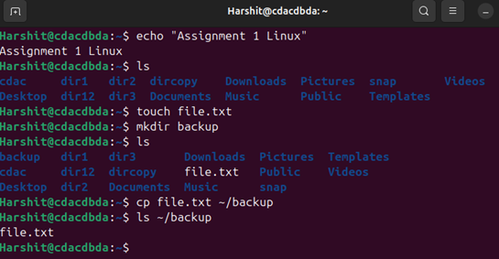

1. What is the difference between the "rm" and "rm -r" commands in Linux?

* rm (remove) command – This command deletes files but can’t delete a directory
* 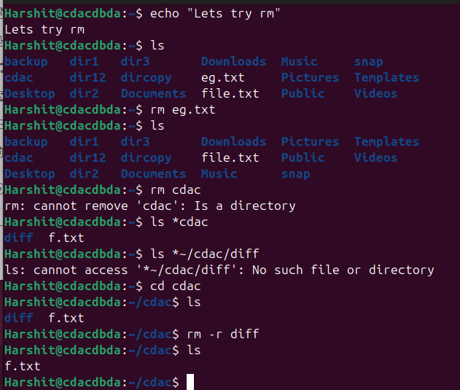rm -r command – This command adds the recursive option allowing it to delete the directory along with its contents with files and subdirectories

1. How do you use the "mv" command to rename a file named "oldname.txt" to "newname.txt"?

1. What does the "pwd" command do in Linux?

pwd – This command prints the current working directory

1. How do you create a new empty file named "newfile.txt" in the current directory using the command line?

1. How do you rename a file named "oldname.txt" to "newname.txt" using the command line?

1. A screenshot of a computer screen

   AI-generated content may be incorrect.How do you remove a file named "file.txt" from the current directory using the command line?
2. Use a command to show the current working directory

1. A screenshot of a computer program

   AI-generated content may be incorrect.List the directory contents in the short and long format
2. Explore attributes given in long format e.g. file type, file permissions, file  size, file owner etc.

|  |  |
| --- | --- |
| Attributes | Description |
| Permissions and File Types | Frist char shows file type (‘d’ – directory and ‘-’ – regular file) followed by 9 chars representing read, write and execute premission |
| Number of Links | Displays Hard links to file or number of entries in directory |
| Owner & Group | Displays file owner and group that owns the file |
| File Size | File Size in Bytes, for directories, size of directory entry not its contents |
| Last Modified Data | The date and time the file was last changed |
| File Name | Displays name of the file or directory |

1. 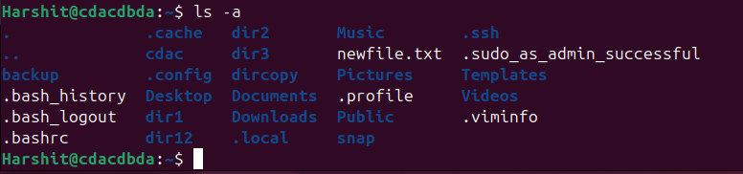List all files along with hidden files in the current working directory.
2. list only hidden files in the directory

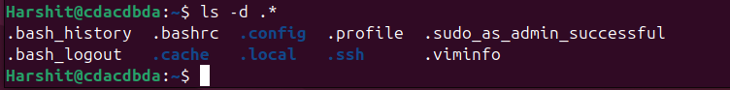

1. Make a directory and name it as cdac-dir ​and change the current working directory to the new directory.(Hint : use mkdir,cd​ commands). 3. Create following nested directories inside the current directory by invoking a single command for only one time. Note : here root_dir is the current directory.  A computer screen with white text

   AI-generated content may be incorrect. A computer screen with white text

   AI-generated content may be incorrect.

Directory structure 1 Directory structure 2

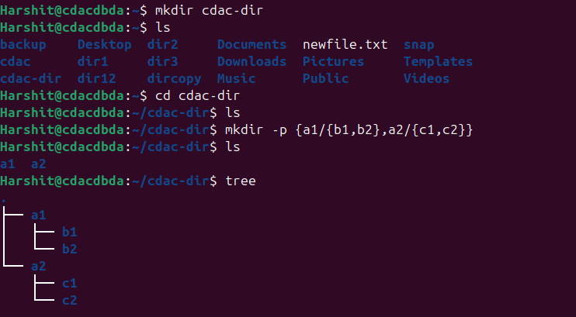List the directories(folders), then remove the cdac-dir ​directory and list the folders again to show that it is no longer present.(Hint : use rm, ls ​command Question-2).

* Dir 1 – mkdir -p {a1/{b1,b2}, a2/{c1,c2}}, mkdir -p a1/b1 a1/b2 a2/c1 a2/c2
* 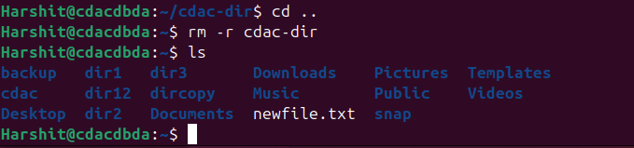Dir 2 – mkdir -p {a1/b1/c1, a2/b2/c2}, mkdir -p a1/b1/c1 a2/b2/c2

1. Display the man-page​ for ls​, but redirect the output into temp.txt​, then use the cat,​ less​, and more​ commands to display the new file.

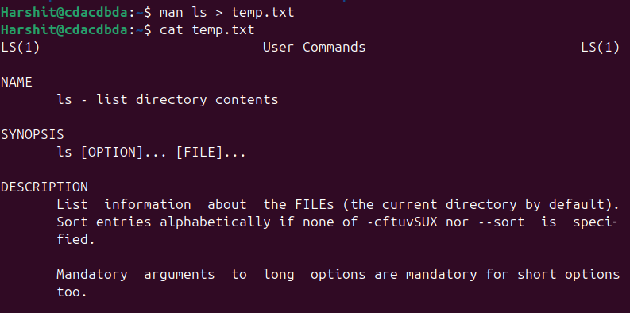

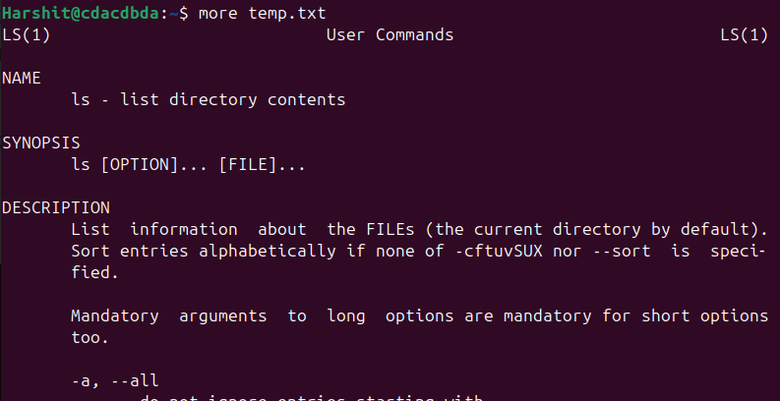

1. 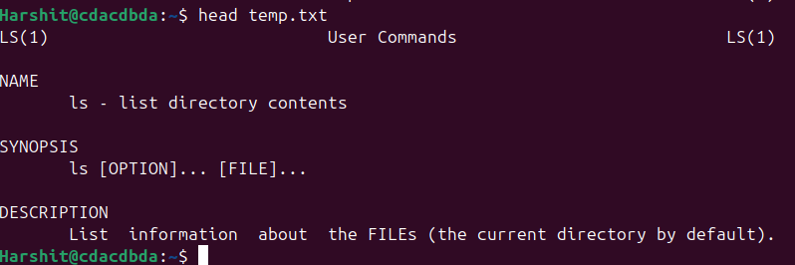 Display the initial 10 lines and final 5 lines of temp.txt​ with the obvious Linux commands.(Hint: use head​ and tail​ commands).

1. Copy temp.txt​ to another directory and rename it there.

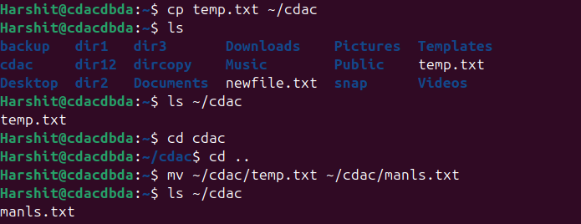(Hint​: use cp​ to copy and mv​ command to rename).

1. Display the number of lines, words and characters in file using Linux command (Hint​: use wc ​command).

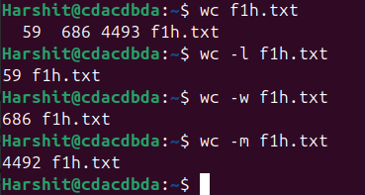

1. Use history command to display the last 10 commands used. (Hint​: use history ​command).

1. 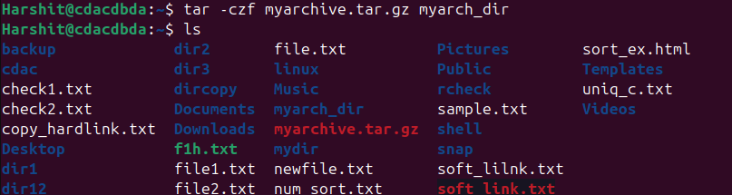Create a tar archive file of any directory present in your home directory. (Hint​: use tar ​command)
2. Create a zip file of another directory. (Hint​: use zip ​command) - list the contents of the zip file without extracting.

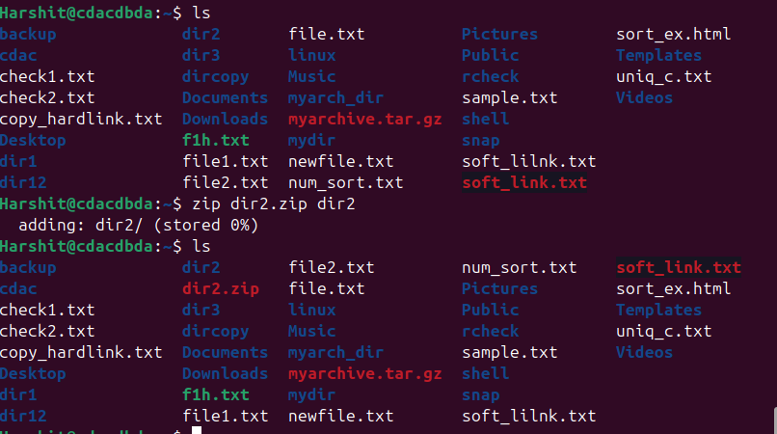

1. A computer screen shot of numbers and numbers

   AI-generated content may be incorrect.Give read, write & execute permissions to your file. (Hint​: use chmod command)
2. Change ownership of that file.(Hint​: use chown​ command)

1. A screenshot of a computer program

   AI-generated content may be incorrect. List processes running in shell, all running processes(Hint​: use man page of ps ​command) and show top processes in decreasing order of their resource utilization.(Hint​: use top​ command).

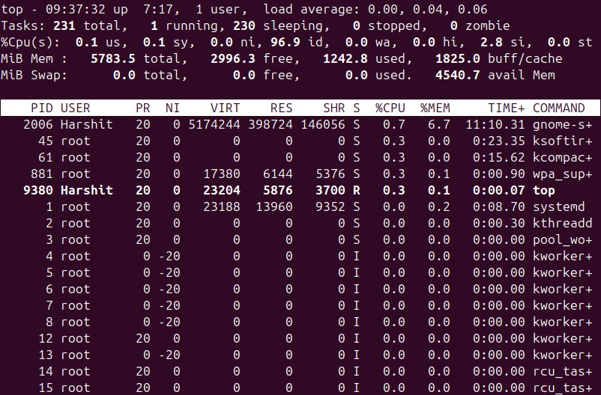

1. A screenshot of a computer

   AI-generated content may be incorrect. Display current time and calendar (Hint​: use date, cal ​commands)
2. Change the current date and time of the system to following 14th March 2024, 10:10 AM
3. A screenshot of a computer program

   AI-generated content may be incorrect.Explore following commands who, whoami, whatis, whereis, (Hint​: use man pages).
4. 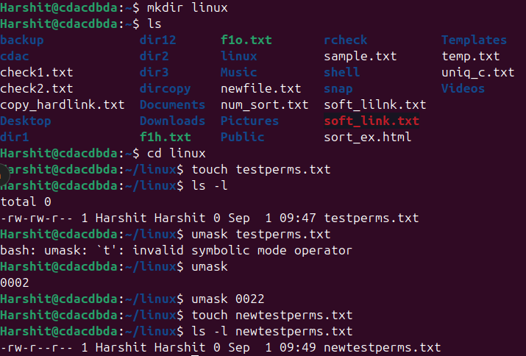 Create one directory named linux. cd to that directory and create one file named testperms.txt. ​Check the permissions of that file. Check the value of umask​. Change the value of umask and create one new file newtestperms.txt ​and check its permissions. Note down the difference.(Hint: use umask, ls command )
5. Create a file and name it as file1.txt and create a hardlink to this file. (Hint: use ln​ command).

1. A computer screen shot of a file

   AI-generated content may be incorrect.Create a file and name it as file2.txt and create a softlink to this file. (Hint: use ln​ command).

|  |  |
| --- | --- |
| Hard Link | Soft link |
| Hard line with being a link. | Soft link is a link which indicates path to  its parent file. |
| Since it is a file by itself, if parent file is  deleted, child file remains as it was  previously. | Since its a path, if parent file is deleted,  child doesn't point tp proper path and  becomes a zombie file. |
| Can be used for creating backup files. | Can be used as a shortcut. |
| Syntax is: In parentfile.ext childfile.ext | Syntax is: In -s parentfile.ext Q  childfile.ext (here, -s indicates soft link) |

1. A screenshot of a computer screen

   AI-generated content may be incorrect.Use ssh​ to connect to your friend's shell by specifying port number​ in the ssh command. use exit ​command to come out of your friends shell. (Hint: use ssh​ command) exit
2. Use scp​ using your friend's credentials to copy a file​ into a directory owned by your friend, ​inside his home directory, specify port number in scp​ command.
3. A screenshot of a computer

   AI-generated content may be incorrect.Use scp​ using your friend's credentials to copy directory​ into a directory owned by you​, inside your home directory, specify port number in scp command
4. Use scp​ using your friend's credentials to copy directory​ into a directory owned by you​, inside your home directory, specify port number in scp command
5. Connect to any publicly available ftp​ server from the terminal and try to download, upload and delete files. If you get error in any process (connect, upload, download or delete), justify the reasons behind them.(Hint: use ftp​ command) Example:

Try to access ftp.netbsd.org

username : anonymous

password : anonymous

1. How do you remove a directory named "mydir" and all of its contents using the command line? A computer screen shot of a program

   AI-generated content may be incorrect.
2. How do you use the "ls" command to list all files and directories in the current directory?

1. How do you create a new file named "myfile.txt" in the directory "/home/user/documents" using the command line?

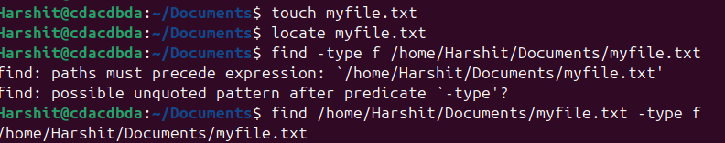

1. How do you use the "grep" command to search for a specific word or phrase in multiple files at once?

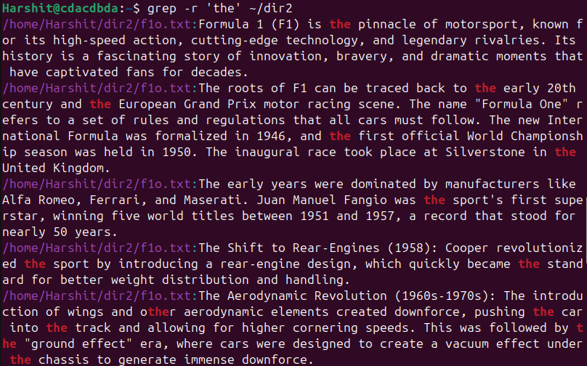

1. How do you create a new directory named "mydir" and set its permissions to read, write, and execute for the owner and read and execute for everyone else?

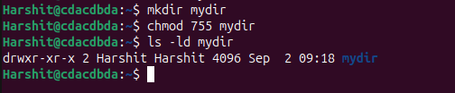

1. How do you use the "tar" command to create a compressed archive of all files in the current directory and its subdirectories?

1. A screenshot of a computer

   AI-generated content may be incorrect.How do you use the "chmod" command to give read and write permissions to the owner and group for a file named "file.txt"?
2. How do you find the size of a file named "file.txt" in bytes, kilobytes, and megabytes using the command line?

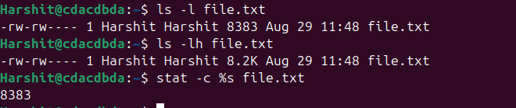

1. How do you use the "awk" command to extract a specific column from a comma-separated value (CSV) file and sort it in reverse order?
2. How do you use the "sed" command to replace all occurrences of a word or phrase in a file with a different word or phrase?

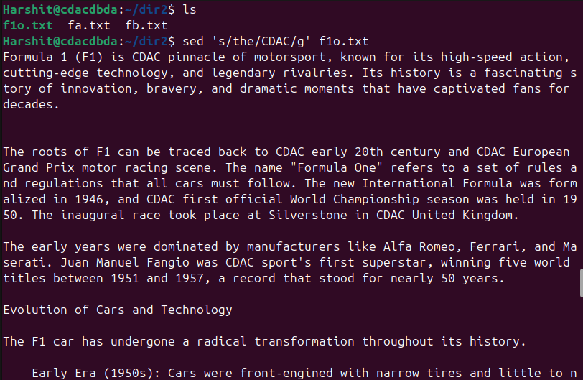

1. How do you use the "find" command to search for all files in a directory and its subdirectories that were modified within the last 24 hours?

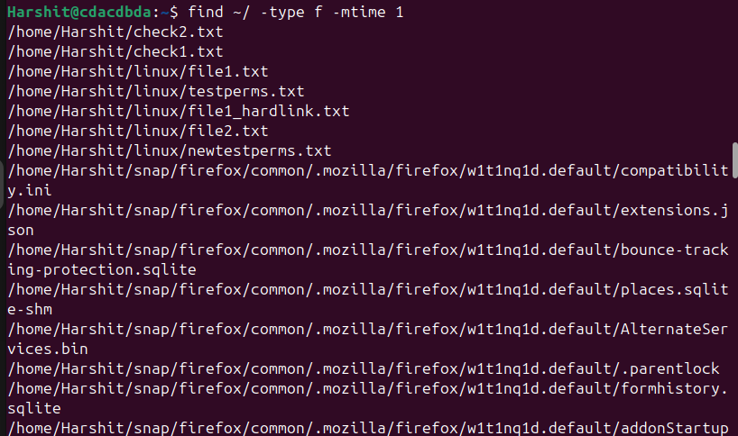

1. 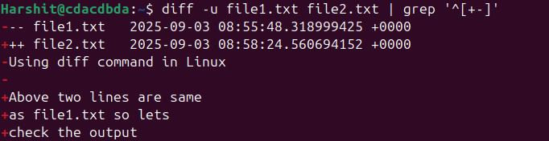How do you use the "diff" command to compare two files and show only the lines that are different between them?
2. How do you use the "rsync" command to synchronize the contents of two directories, including all subdirectories and files, while preserving file permissions and ownerships?

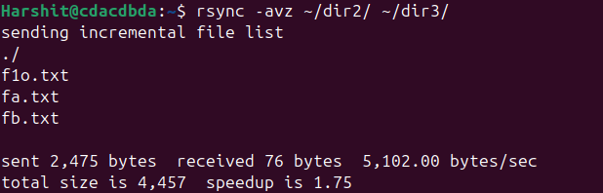

1. How do you use the "cut" command to extract a specific range of characters or bytes from a file?

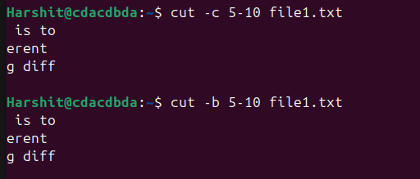

1. 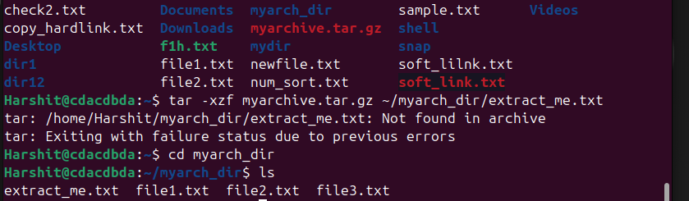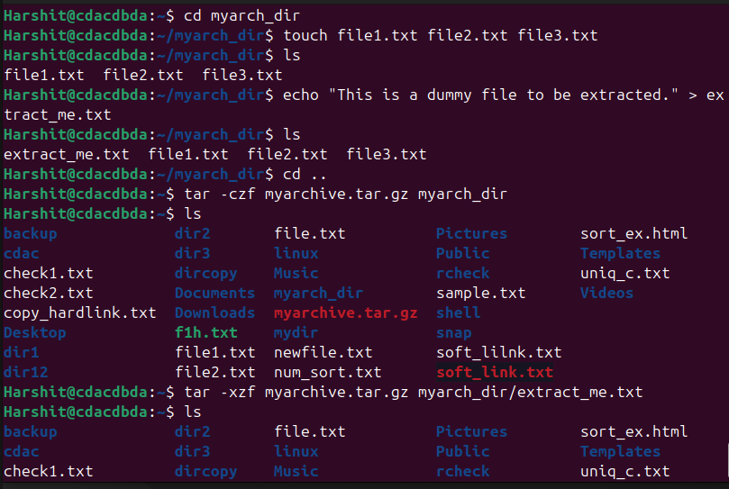How do you use the "tar" command to extract a specific file or directory from a compressed archive without extracting the entire archive?
2. How do you use the "awk" command to count the number of occurrences of a specific word or phrase in a file?